EASTERN INTERNATIONAL UNIVERSITY SCHOOL OF COMPUTING AND INFORMATION TECHNOLOGY
aa
Practice Assignment – Quarter …, 20…-20… Course Name: Special Topic 1
Course Code: CSE 484
Student’s Full Name: Hà Quang Minh
Student ID: 1931220012

Lab 6
Background
This 3-hour lab applies model-driven automation on a Cisco CSR1000v using RESTCONF and NETCONF (ncclient), with a quick CLI parity check (Netmiko + TextFSM). You’ll enable the right services, fetch structured data, make safe transactional changes, and capture evidence for your report.
Required Resources:

- 1 PC (Linux/macOS/WSL recommended) with Python 3.9+ and VS Code
- A CSR1000v (or IOS-XE device) reachable from your PC
- Internet access to install packages: requests, ncclient, lxml, netmiko
- Credentials with privilege 15 on the CSR

Problem:

Part 1 — Connectivity & Feature Enablement

Enable services on CSR (CLI):
conf t
username cisco privilege 15 secret cisco ip domain-name lab.local
crypto key generate rsa modulus 2048 ip http secure-server
ip http authentication local restconf
netconf-yang line vty 0 4
transport input ssh

login local end

Verify reachability: ping <CSR_IP> and ssh cisco@<CSR_IP> (port 22).
- Create venv + install libs
python -m venv .venv && source .venv/bin/activate pip install requests ncclient lxml netmiko

Evidence: screenshot of SSH login; command outputs confirming services.

Part 2 — RESTCONF Reads & Patch
Goal: pull JSON, then make a small, safe change.

GET all interfaces (JSON):
curl -k -u <<admin>>:<<password_of_admin>> -H "Accept: application/yang-data+json" "https://<CSR_IP>/restconf/data/ietf- interfaces:interfaces/interface"

GET one interface and operational state.
- Config:
.../restconf/data/ietf-interfaces:interfaces/interface=GigabitEthernet1
- State:
.../restconf/data/ietf-interfaces:interfaces-state/interface=GigabitEthernet1

PATCH a description on Gi1.
curl -k -u cisco:cisco -X PATCH -H "Content-Type: application/yang- data+json"
"https://<CSR_IP>/restconf/data/ietf- interfaces:interfaces/interface=GigabitEthernet1" -d '{ "ietf- interfaces:interface": { "name":"GigabitEthernet1", "description":"LAB-Gi1", "type":"iana-if-type:ethernetCsmacd", "enabled": true } }'
- Verify: RESTCONF GET again and CLI “show run int g1 | i description”.

Evidence: JSON snippets before/after changes made; CLI verification.

Part 3 — NETCONF with ncclient
Goal: discover models; do a transactional hostname change.

Discover capabilities.
# discover_caps.py
from ncclient import manager
with manager.connect(host="<CSR_IP>", port=830, username="cisco", password="cisco",
hostkey_verify=False, look_for_keys=False, allow_agent=False) as m:
for cap in m.server_capabilities: print(cap)

Safe config flow (lock → load → validate → commit → unlock).
# set_hostname_nc.py
from ncclient import manager
from ncclient.xml_ import new_ele, sub_ele, to_xml

cfg = new_ele("config")
native = sub_ele(cfg, "native", xmlns="http://cisco.com/ns/yang/Cisco-IOS- XE-native")
sub_ele(native, "hostname").text = "CSR-DEMO"

with manager.connect(host="<CSR_IP>", port=830, username="cisco", password="cisco",
hostkey_verify=False, look_for_keys=False, allow_agent=False) as m:
target = "running" # use "candidate" if supported on your image m.lock(target)
try:
m.edit_config(target=target, config=to_xml(cfg))
if any(":validate" in c for c in m.server_capabilities):

m.validate()
if target == "candidate": m.commit()
finally:
m.unlock(target)
- Verify: RESTCONF .../native/hostname (or CLI show run | i hostname). Evidence: capability list, NETCONF reply XML, verification output.
Part 4 —Netmiko
Goal: CLI automation: structured parsing, config with verification, concurrency, logging, error- handling.

Set env vars (safer than hard-coding):
Create an .env file with following contents:
export NET_HOST=<CSR_IP>
export NET_USERNAME=<user-name> export NET_PASSWORD=<password> #export NET_ENABLE=cisco (optional)

Gather structured data (TextFSM) + anti-paging + prompts/modes
# nm_gather.py import os, json
from netmiko import ConnectHandler

dev = {
"device_type": "cisco_ios", "host": os.getenv("NET_HOST"),
"username": os.getenv("NET_USERNAME"), "password": os.getenv("NET_PASSWORD"), "secret": os.getenv("NET_ENABLE"),
"session_log": "session_csr.txt", # raw send/recv transcript
}
with ConnectHandler(**dev) as net:
print("Login prompt:", net.find_prompt()) # e.g., "CSR1kv>"

net.enable() # -> privileged "#" net.send_command("terminal length 0") # disable paging

brief = net.send_command("show ip interface brief", use_textfsm=True)
ver = net.send_command("show version") print(json.dumps(brief, indent=2)[:500]) open("cli_show_ip_int_brief.json", "w").write(json.dumps(brief,
indent=2))
open("cli_show_version.txt", "w").write(ver)
Evidence: image of cli_show_ip_int_brief.json, cli_show_version.txt

Handling slow devices & flaky links
# nm_slow_device.py
from netmiko import ConnectHandler import os
dev = {"device_type":"cisco_ios","host":os.getenv("NET_HOST"),

"username":os.getenv("NET_USERNAME"),"password":os.getenv("NET_PASSWO RD"),
"secret":os.getenv("NET_ENABLE")} with ConnectHandler(**dev) as net:
net.enable()
net.global_delay_factor = 2 # make all ops more patient out = net.send_command("show tech-support", delay_factor=4,
read_timeout=120) print(out[:800])
Evidence: image of the print command

Config from file + per-device logs
Create a txt file named changes.txt containing some line as follows:
logging buffered 19999 no ip http server

Create and run a python file:
# nm_from_file.py
from netmiko import ConnectHandler import os, time
cmdfile = "changes.txt" # create with a few lines, e.g., "service timestamps debug datetime msec"
dev = {"device_type":"cisco_ios","host":os.getenv("NET_HOST"),

"username":os.getenv("NET_USERNAME"),"password":os.getenv("NET_PASSWO RD"),
"secret":os.getenv("NET_ENABLE"), "session_log":"session_apply.txt"}
with ConnectHandler(**dev) as net: net.enable()
out = net.send_config_from_file(cmdfile) open("cfg_from_file.txt","w").write(out)
Evidence: image of the cfg_from_file.txt file

My Solution:
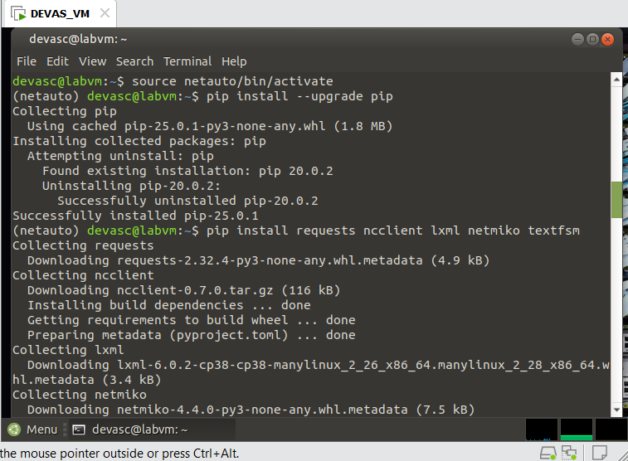
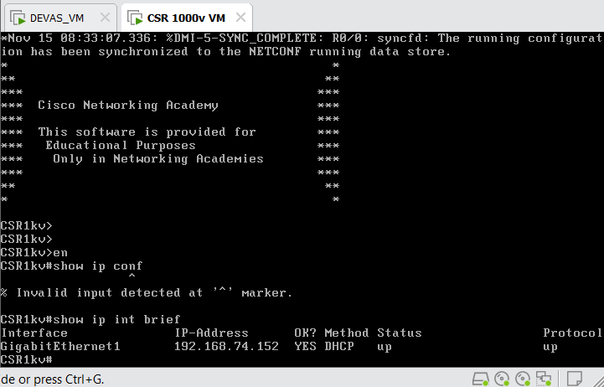
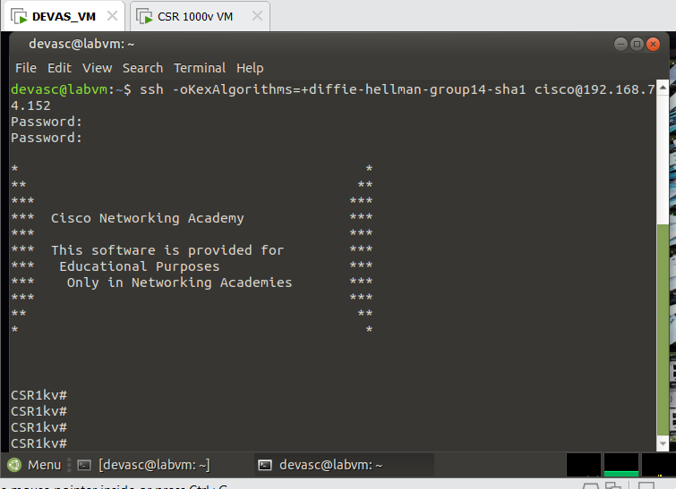

ssh -oKexAlgorithms=+diffie-hellman-group14-sha1 cisco@192.168.74.152
Pass : cisco123!

Part 3:
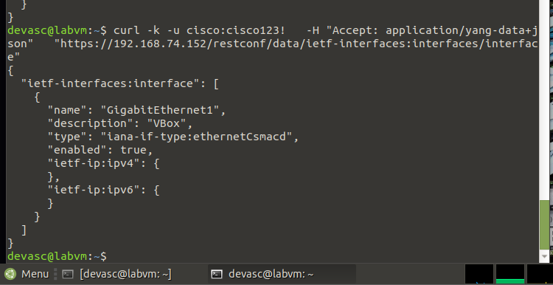
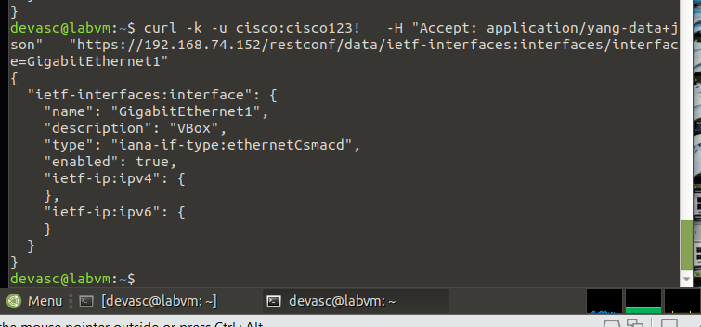
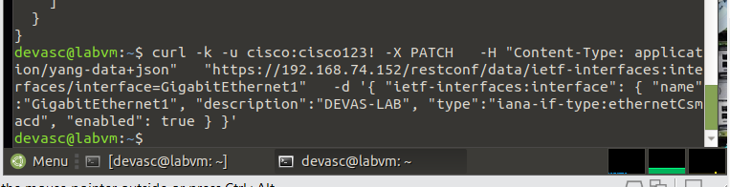
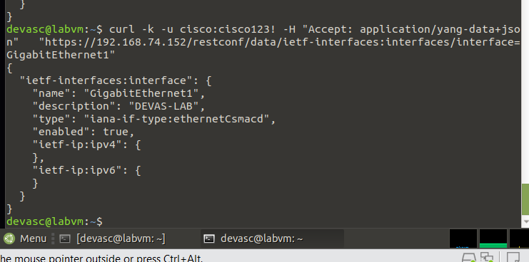

PART 4:
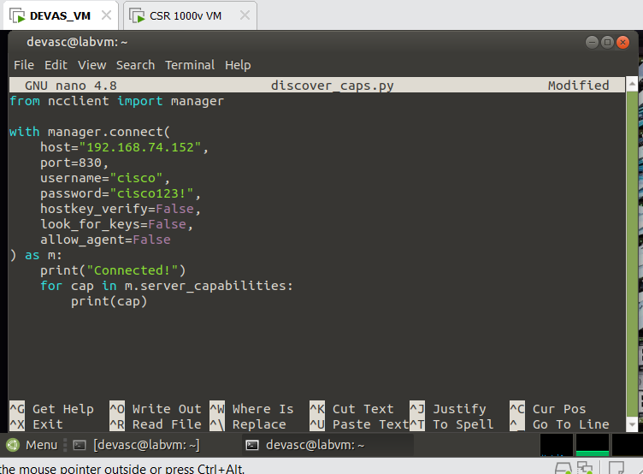
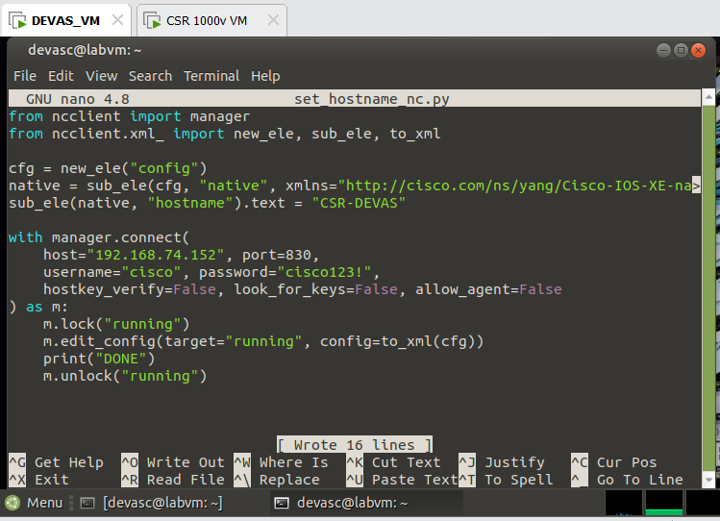
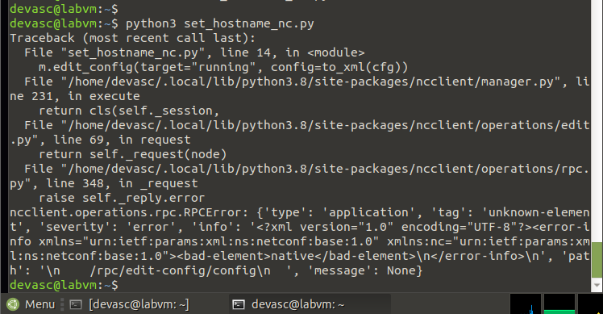
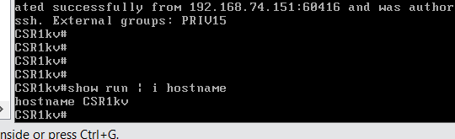

PART 5:
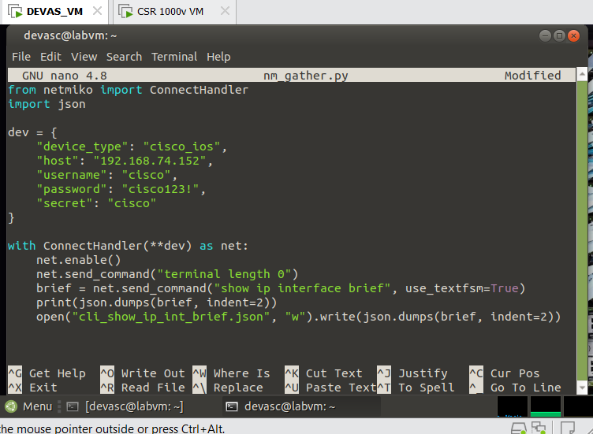
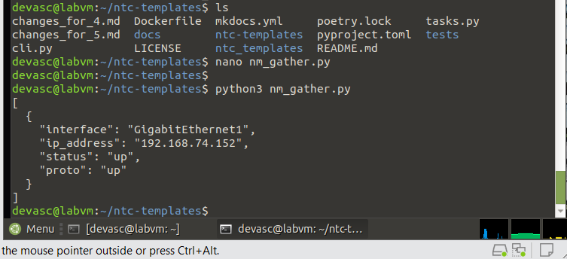
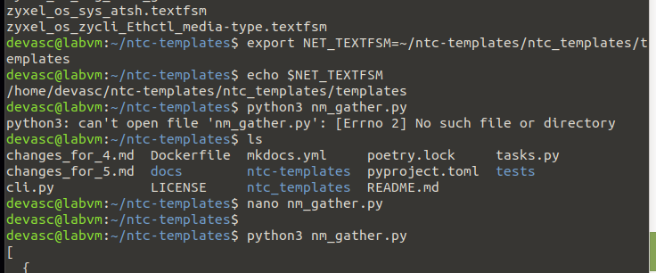

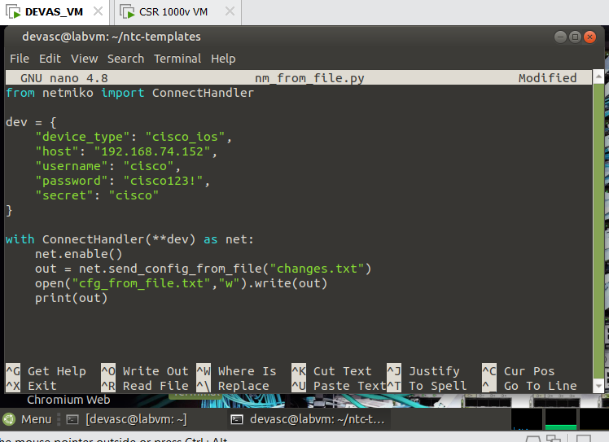
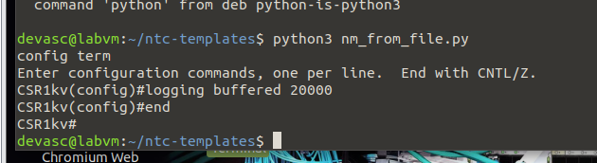

Submission: Must include:
- a pdf report file containing your information (student id, name), and images of the diagrams, codes, answers, evident,…
- and all source code files (if any)
in a zipped (.zip or *.rar) file to Moodle

